Allow Flash in Microsoft Edge:
- On a Page that has blocked or won’t run flash
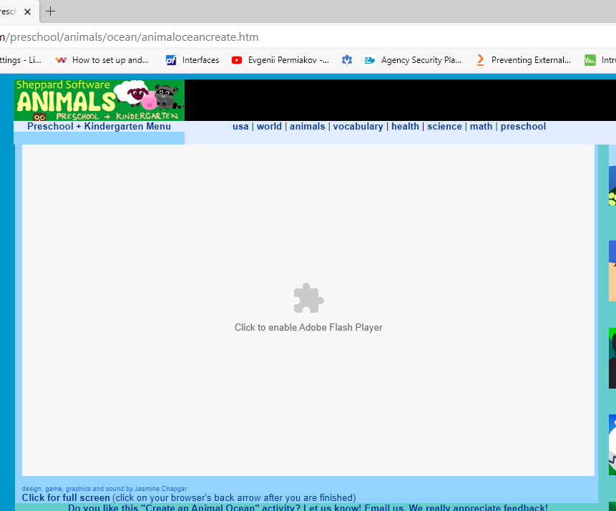
- Click on the puzzle piece in the middle of the page, or the “lock” icon next to the URL address bar
- In the notification box that appears, click allow to run the flash element

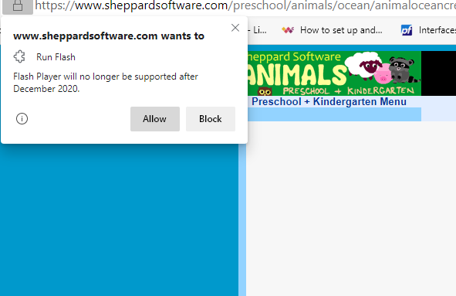
- If you receive an error or the page crashes and refreshes.
- Click the puzzle piece at the top right of the browser and select Always Allow for a trusted site
- Then reload the page. The site should now remember that selection and run all flash elements, but depending on browser updates may need to be slected at every visit
​
