To run a flash element in chrome:

Step 1: Find the grey box marked “Click to enable Flash Player” on the webpage.
When you encounter a site that uses Flash, you should see a notice to enable flash. It appears as a blank grey box with “Click to enable Adobe Flash Player” and the outline of a puzzle piece. That’s where your Flash content is located.
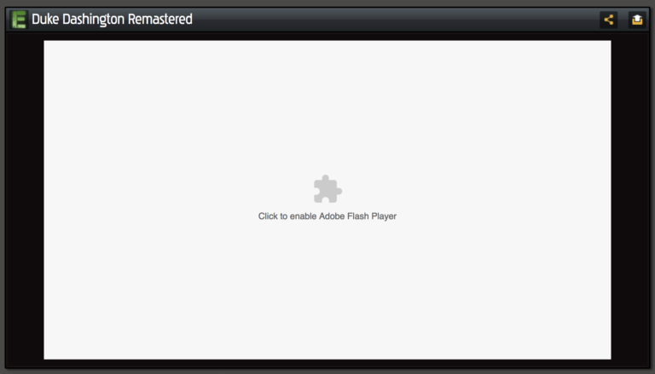

Step 2: Click the button (grey box area) and then confirm again in the pop-up
When you select “Click to enable Adobe Flash Player,” a pop-up will appear at the top of the screen. Select the “Allow” button. This will reload your current page.
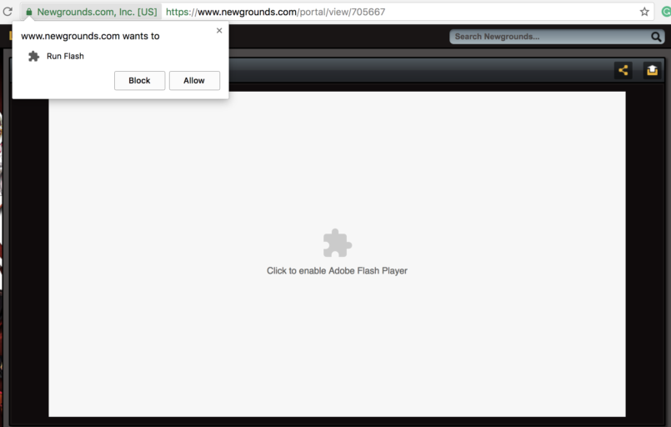

To enable/activate flash in chrome:

Step 1: Go to Content Settings
Rather than being forced to navigate through menus, the easiest way to access Chrome settings is via the address bar. Enter chrome://settings/content into the address bar and press enter. (this option can also be found in the setting smenu)
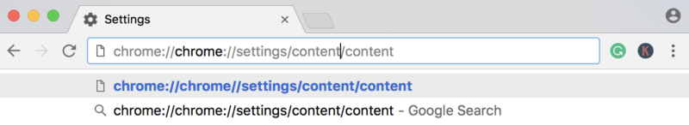

Step 2: Scroll to the Flash tab
Towards the bottom of the Content Settings menu, under JavaScript, you will locate the Flash tab. Select it.
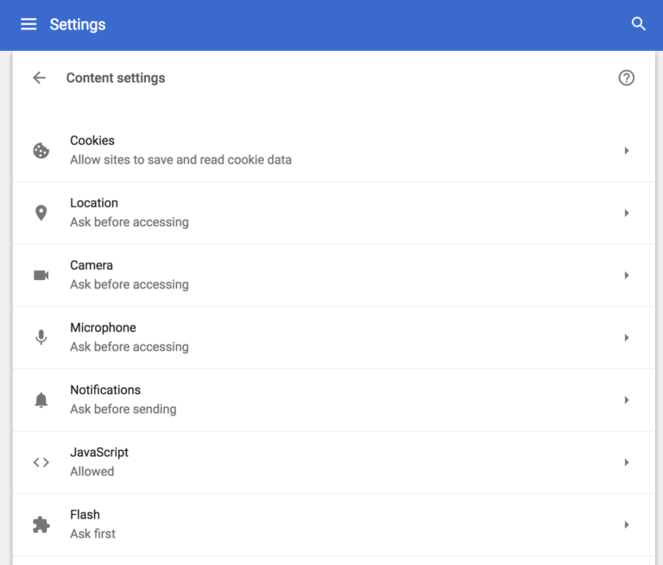

Step 3: Turn off “Block sites from running Flash.”
Once you turn off the “Block sites from Running Flash” button, you’ll notice the feature is now set to “Ask first.” From this point on, when you encounter a Flash plug-in, you’ll be asked if you want to activate it for that particular site.
