Integrating Google Classroom with Studies Weekly Online

Getting Started
To connect your Studies Weekly account to your Google Classroom, your students’ Studies Weekly usernames must be their Google Classroom email.
For those that want to use the integration now, you will need to log in to your account and manually change your students’ usernames to their Google Classroom email.

1. Select your classroom in the Studies Weekly platform
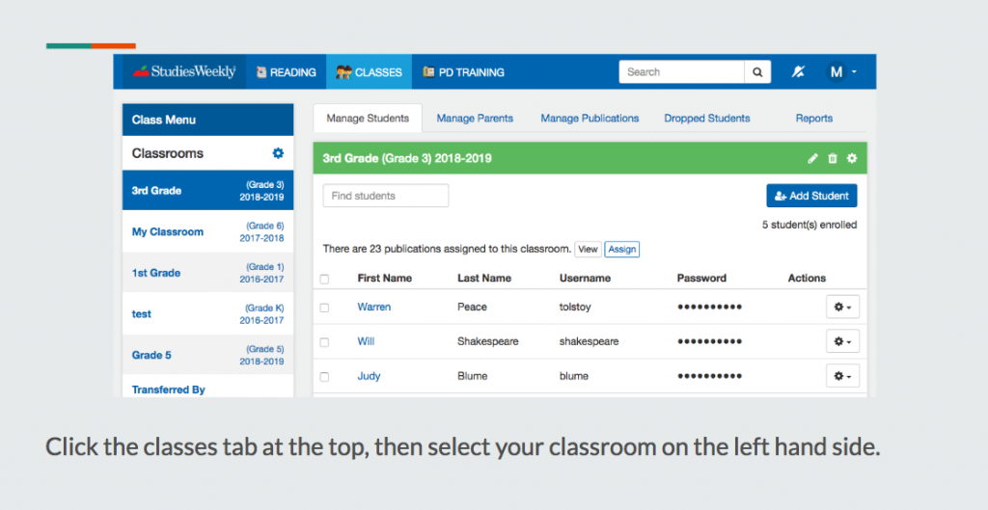

2. Navigate to edit each student
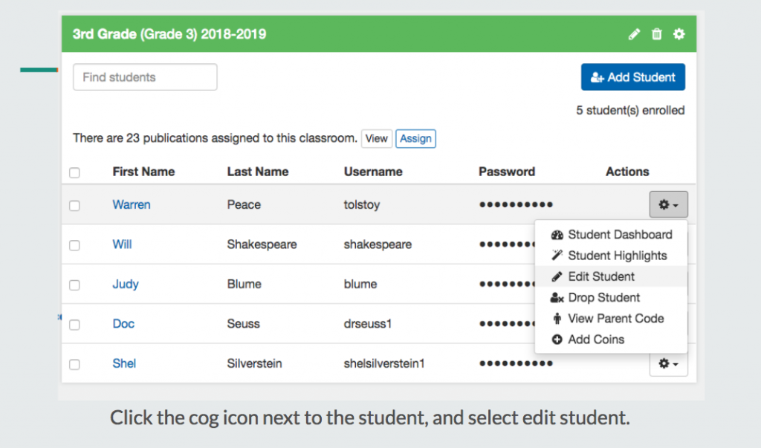

3. Edit the student’s username
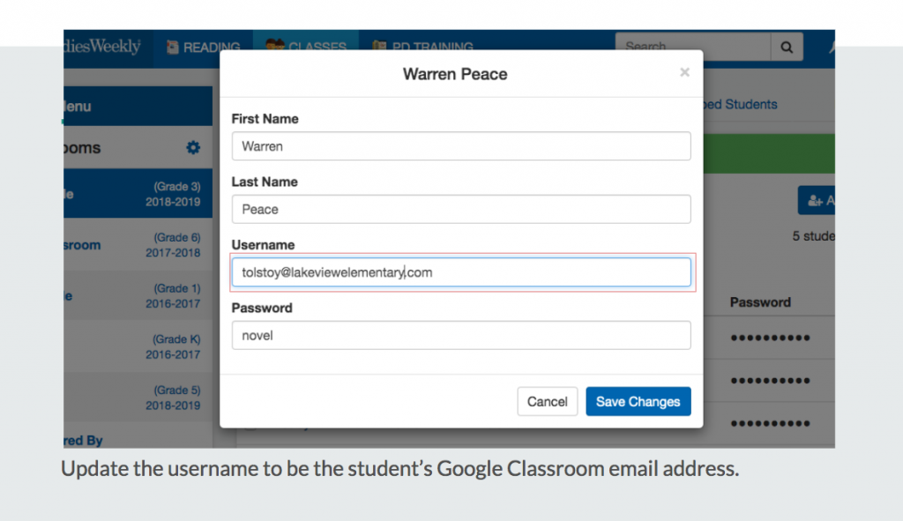
At the beginning of each school year, your auto-rostering program can link both platforms, but make sure to check this username requirement for all students.

How to use the Integration

1. From an article, navigate to the Google Classroom Icon in the corner.
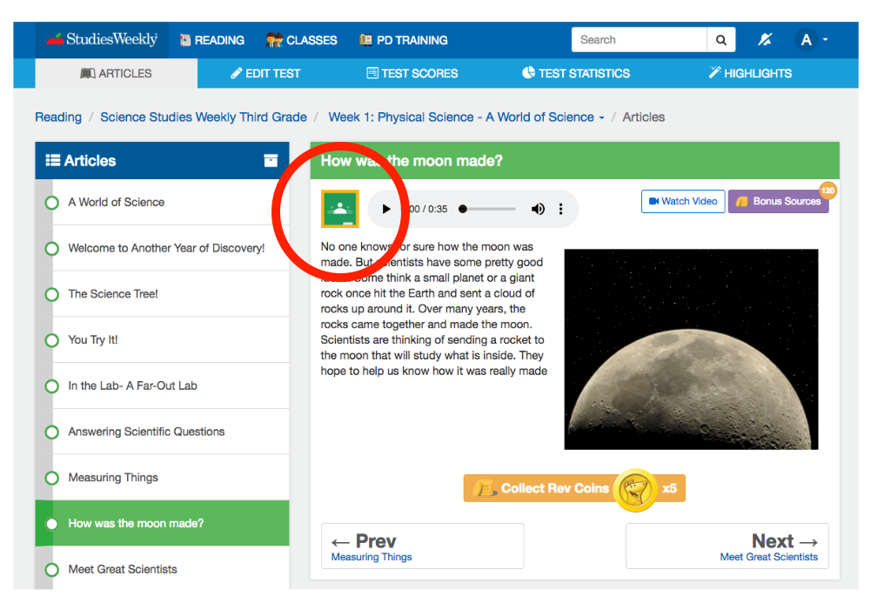

2. Click on it, and select the Classroom you are sharing it to, and the action from the Classroom options. Click “Go.”
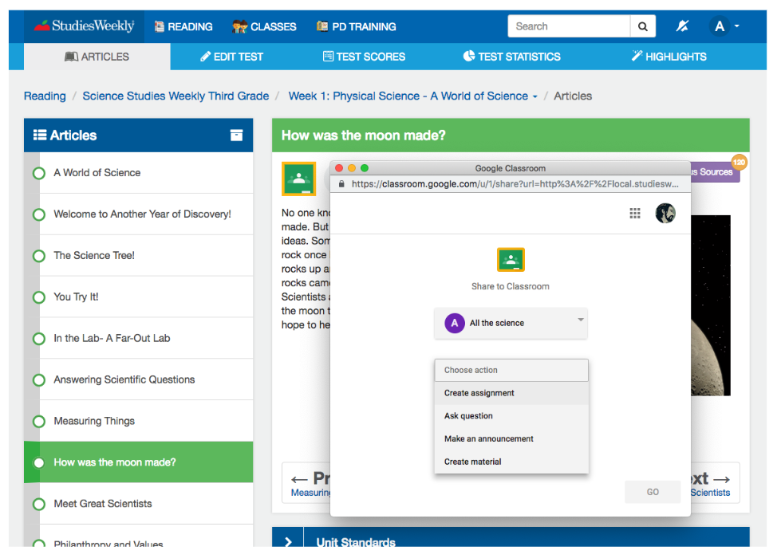

3. Add your own notes, points, due date, etc. Click “Assign.”
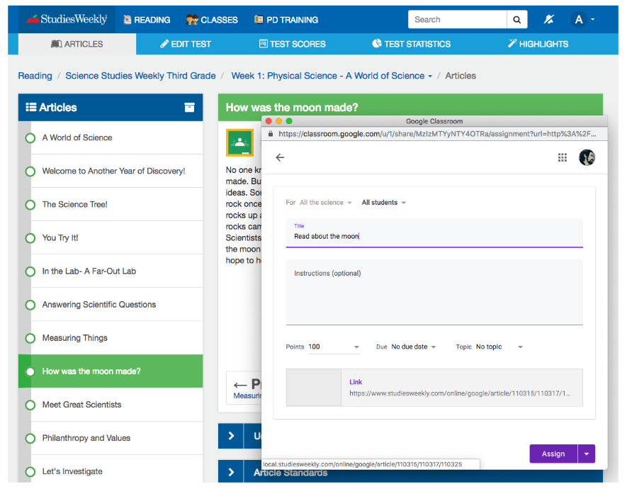

4. The assignment shows up in your students’ Classroom stream.

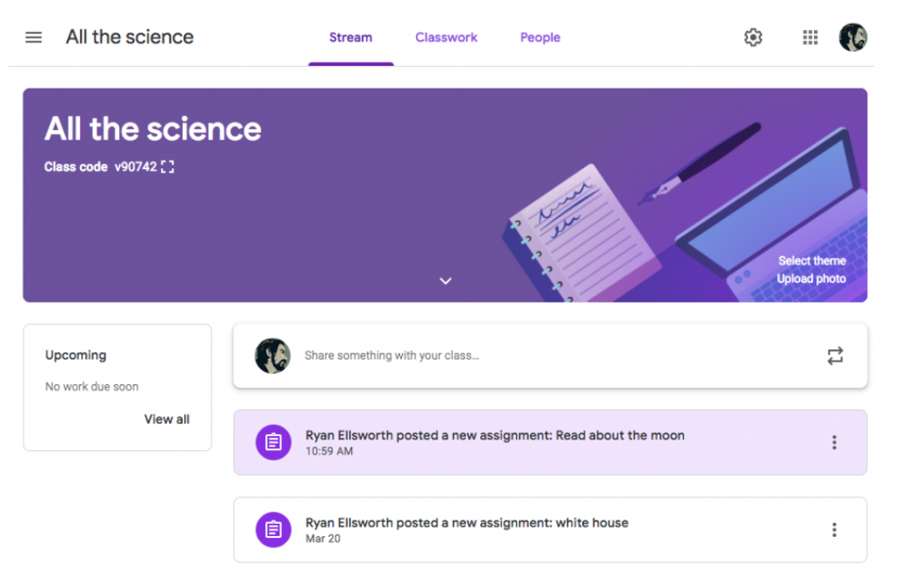

Assigning Specific Sources
You can also assign specific audio, images or videos from an article, or search for them and assign them individually. To do so, simply look for the Google Classroom icon on each source.

Images
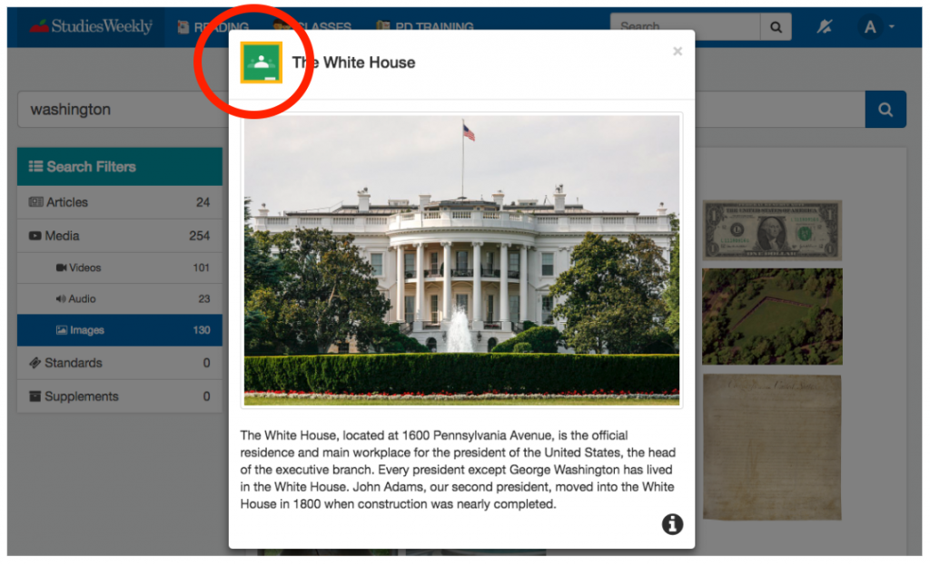

Audio
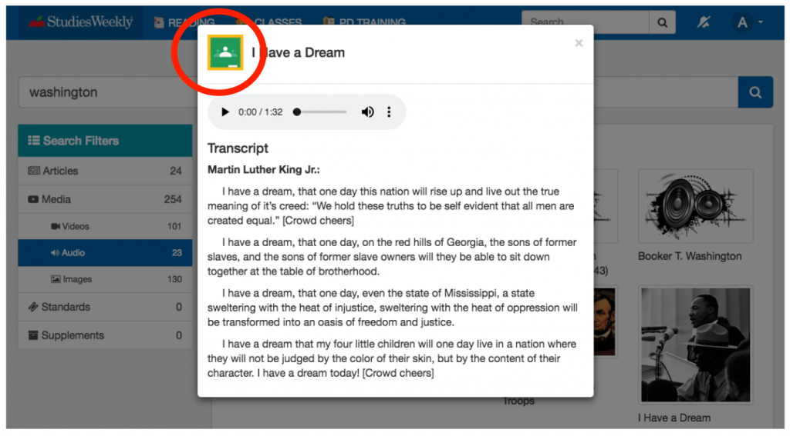

Videos
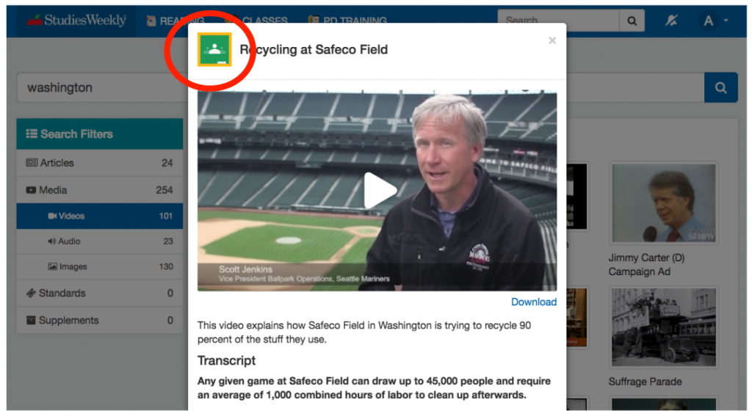

Of course, all Assessments, Crosswords and Mispilled are integrated as well.
